## Lab 2-02: Applying Labels on Compute Engine Instances using Console

### Lab Prerequisites

* Familiarity with basic Google Cloud Computing concepts and terminology.
* A Google account with an active subscription.

### Service Introduction

GCP labels, or Google Cloud Platform labels, are metadata tags that can be applied to resources such as virtual machines, storage buckets, and other cloud services within the Google Cloud Platform. These labels help users to organize and identify their resources by providing additional contextual information about them.

Case Study IT Solutions – IPSpecialist

Background

IPSPECIALIST is a small but dynamic book production company that specializes in creating high-quality study materials for IT certification exams. Their team of experienced authors and editors is dedicated to producing informative and engaging content that helps aspiring IT professionals pass their certification exams on the first try. Whether customers are studying for Cisco CCNA, Cloud certifications, or any other IT certification, their books are designed to provide the knowledge and skills needed to succeed. They take pride in their commitment to quality and strive to make their materials accessible and easy to understand, no matter your level of expertise.

### Business Challenge

They have been using GCP for their operations, and as they are just starting up, resource sharing among employees is very common. A problem has occurred in which employees mistakenly use resources already used by other employees. This causes interruption and delays in the working environment.

To counter this issue, the company has asked you, a Cloud Architect, to propose a solution.

### Proposed Solution

As a Cloud Architect, you suggest they use labels on their resources to limit resource sharing problems.

Lab Diagram

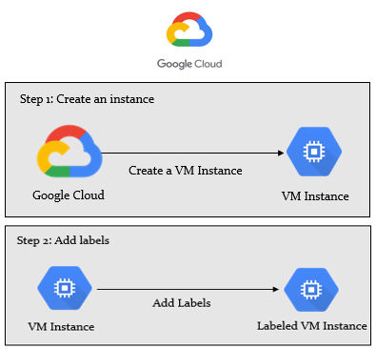

Figure 2-05: Lab diagram

Implementation Steps

1. Create a VM instance and add a label.
2. Edit the label on the instance.

Solution

|  |
| --- |
| Create a compute engine instance and apply labels to it by using the GCP Console. You can also add, eliminate, or update the current labels.   1. Log in to GCP Console.      1. Create an example instance using GCP Console. 2. Go to “Navigation Panel” > “Compute Engine” > “VM Instance”.      1. Create an instance.      1. Select the f1-micro instances.      1. For the addition of Labels, just expand this.      1. Click on “Add label”.      1. Add the labels.      1. Create an instance.      1. The instance is running.      1. Select the instance and click on “SHOW INFO PANEL”.      1. Click on “LABELS”. 2. Here, you can add additional labels. 3. Remove labels and edit the value of the label. 4. Save the changes.      1. Activate Cloud Shell. 2. Create an instance using the following command:   “gcloud compute instances create [instance-name] –labels key=value,key=value”.     1. The instance is created with the described labels.        1. You can list the existing labels using the command “gcloud compute instances describe [instance-name] --format ‘default(labels)”.      1. To update the instance label on an existing resource, use the following command: “gcloud compute instances update [instance-name] --update –labels key=value, key=value”.        1. To remove an instance label, you can use the command “gcloud compute instances update [instance-name] --remove –labels key1, key2”.      1. If you do not specify the region at the beginning, you will be prompted to specify the region of the instance.      1. This will delete the instance label. |